CFAES STANDARD OPERATING PROCEDURE
Disinfectants & Cleaning Detergents Livestock Use

According to the Safety Data Sheet (SDS) special precautions must be taken when working with the chemical described above. The following information includes the chemical characteristics of the below list of chemicals followed by recommendations for handling and any paperwork needed in order to use the chemical in the laboratory. This Standard Operating Procedure will be followed along with the requirements of the Hazcomm Plan.

Products: Alconox
Chlorhexidine (hydrochloride)
Nolvasan
Virox Accel (concentrate)
Virox INTERVention

GHS Classifications: Signal Words: Warning
Pictograms: 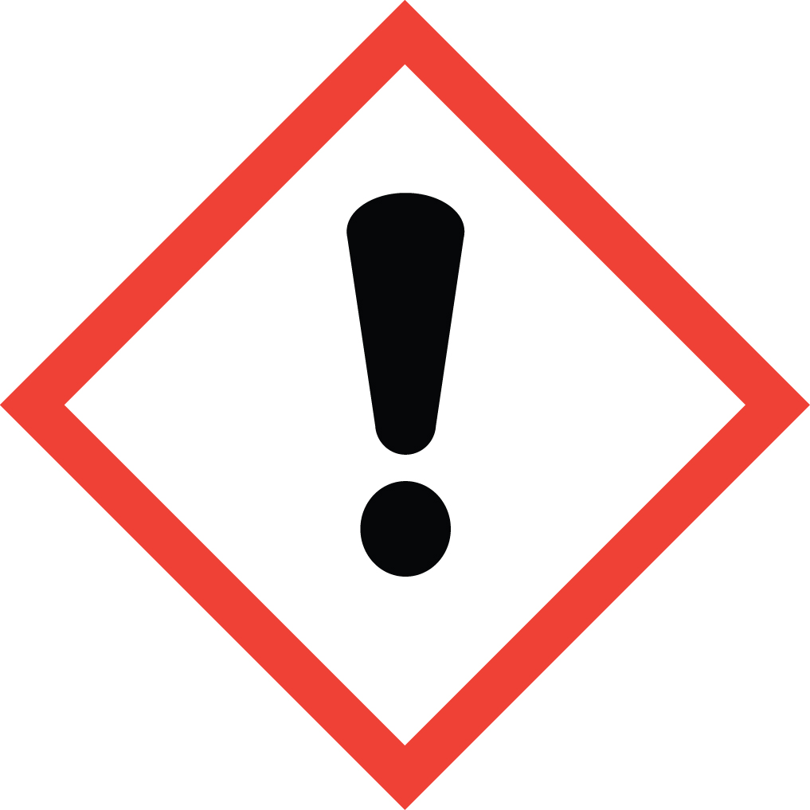

Additional Classification: Potential Hazards
May cause skin irritation.
May causes serious eye irritation.
May cause respiratory irritation.
Use outdoors or in well ventilated area

Brief description of proposed chemical work: Products used as a disinfectant or cleaning material / detergent in research livestock areas. Follow all label directions for use.

Section 1: Brief Safety Overview:
● The Principal Investigator is responsible for training employees using the material on site. The training should include a discussion of the known and potential hazards; an explanation of the relevant policies, techniques and procedures including the proper use of personal protective equipment, emergency/spill procedures and containment equipment (engineering controls).
● Limit access to authorized users.
● Minimize the possibility of inadvertent ingestion, inhalation and direct skin or eye contact with the substance.
● Chemical has been entered in the Chemical Inventory (EHS Assistant)
● Require annual training.

Section 2: Research Laboratory Procedures
Work Practice Controls
• ALWAYS review the SDS any chemicals/agents before use.
• NEVER mix with an unknown liquid or unknown residue.
• Work with the smallest practicable amount and lowest practicable concentration.

Storage:
Store in original container protected from direct sunlight in a dry, cool and well-ventilated area, away from incompatible materials. Keep container tightly closed and sealed until ready for use. Containers that have been opened must be carefully resealed and kept upright to prevent leakage. Do not store in unlabeled containers. Use appropriate containment to avoid environmental contamination. Empty containers retain product residue and can be hazardous. Do not reuse container.

Location – Engineering controls
- Engineering controls should be the primary means to control exposures.
• An eyewash/drench hose combination unit must be available in the immediate work area for any work with corrosive materials.
• A system of local and/or general exhaust is recommended to keep employee exposures below Permissible Exposure Limits (PEL). Local exhaust ventilation (LEV) is generally preferred because it can control the emissions of the contaminant at its source, preventing dispersion of it into the general work area. Contact OSU EHS for a determination of the need for an LEV system, if there is not one available.
-Remove contaminated clothing and protective equipment before entering eating areas. Workers should wash hands and face before eating, drinking and smoking. Put on appropriate personal protection equipment. Eating, drinking and smoking should be prohibited in areas where this
material is handled, stored and processed.

PPE required:
In order to select the appropriate PPE for the workplace, a Hazard Assessment should be conducted. The Hazard Assessment determines the hazards and potential hazards associated with a task, machinery, or process. The appropriate PPE for the situation may be subsequently determined. Contact OSU EHS for a Hazard Assessment. Refer to label and SDS of product for specific PPE requirements.

Respiratory protection : NIOSH approved respirator, as product / conditions warrant

Skin protection : Wear suitable protective clothing and gloves. Suitable protective footwear. Protective gloves should be compatible chemical – resistant gloves

Eye/face protection : If contact with product is possible, wear safety glasses with side shields, chemical splash goggles and/or face shield.

- Cleanup/Decontamination procedures for work area after use:

Accidental Release / Spill Procedures
Personal Precautions, Protective Equipment and Emergency Procedures
Ensure adequate ventilation. Personnel involved in clean-up should wear appropriate personal protective equipment.
Environmental Precautions
Place waste in an appropriately labeled, sealed container for disposal. Care should be taken to avoid environmental release.
Methods and Material for Containment and Cleaning Up
Measures for Cleaning / Collecting:
Contain the source of spill if it is safe to do so. Collect spill with absorbent material. Clean spill
area thoroughly.
Additional Consideration for Large Spills:
Non-essential personnel should be evacuated from affected area. Report emergency
situations immediately. Clean up operations should only be undertaken by trained personnel.

Disposal Procedures
The generation of waste should be avoided or minimized wherever possible. This material and its container must be disposed of in a safe way. Care should be taken when handling emptied containers that have not been cleaned or rinsed out. Empty containers or liners may retain some product residues. Avoid dispersal of spilled material and runoff and contact with soil, waterways, drains and sewers. Dispose of via a licensed waste disposal contractor.

Section 3: Occupational Exposures

- Occupational Exposure Response and First Aid Measures

Eye Contact: If irritation occurs or persists, get medical attention. Flush eyes with water for at least 15 minutes.

Skin Contact: Remove contaminated clothing and wash exposed area with soap and water. Obtain medical assistance if irritation occurs.

Ingestion: Never give anything by mouth to an unconscious person. Wash out mouth with water. Do not induce vomiting unless directed by medical personnel. Seek medical attention immediately.

Inhalation: Remove to fresh air and keep patient at rest. Seek medical attention immediately.

This Standard Operating Procedure must be placed in the Hazard Communication Plan and the SDS must be accessible. Also, all personnel must be familiar with safe handling practices (i.e., training with documentation of training) when working with these chemicals. This must be incorporated into the comprehensive hazcomm plan of the laboratory. If you have any questions regarding a comprehensive mandatory laboratory chemical hygiene plan please contact your Representative at Environmental Health and Safety (292-1284). For any other questions or concerns, please contact:

PI contact information
Name:
Primary Contact Number:
Emergency Contact Number:

P.I. Signature ___________________________________________________________

