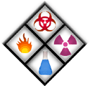
CFAES STANDARD OPERATING PROCEDURE
Spore-klenz - Ready to Use

According to the Safety Data Sheet (SDS) special precautions must be taken when working with the chemical described above. The following information includes the chemical characteristics of Spore-klenz followed by recommendations for handling and any paperwork needed in order to use the chemical in the laboratory. This Standard Operating Procedure will be followed along with the requirements of the Hazcomm Plan.

GHS Classifications: Signal Words: DANGER
Pictograms: 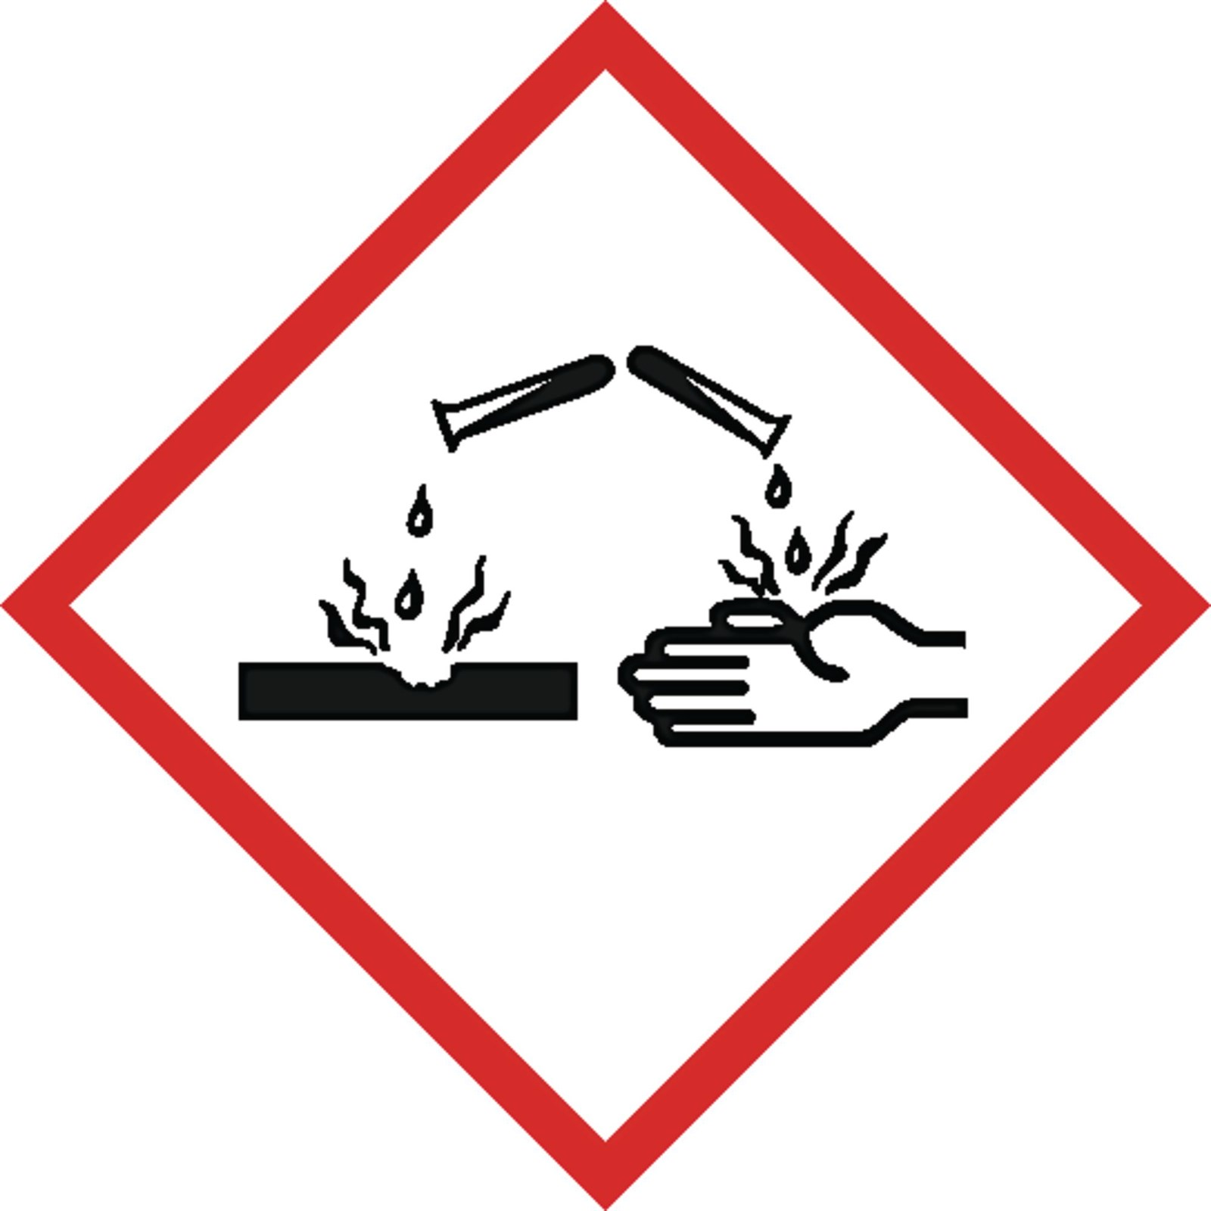

Additional Classification: Potential Hazards
Causes serious eye damage. Causes skin irritation. May cause respiratory irritation.
Severe skin irritant. Effects of skin contact may include: irritation and burn feeling.
Ingestion: may cause burns or irritation of the linnings of the mouth, throat, and gastrointestinal tract. May cause nausa, vomiting, and diarrhoea.

Brief description of proposed chemical work: Spor-Klenz Ready-To-Use (RTU) Cold Sterilant is an Environmental Protection Agency (EPA) registered product designed to be used as a sterilant, sporicide or as a disinfectant for cleanroom environmental surfaces and equipment in the pharmaceutical, biotechnology, medical products manufacturing, cosmetics and nutritionals industries. Spor-Klenz RTU sterilant may also be used in research facilities, including laboratory animal research facilities.

Spor-Klenz RTU sterilant is a stabilized blend of peracetic acid, hydrogen peroxide and acetic acid. This chemistry provides for fast, effective microbial control, including spores.

Section 1: Brief Safety Overview:
● The Principal Investigator is responsible for training employees using the material on site. The training should include a discussion of the known and potential hazards; an explanation of the relevant policies, techniques and procedures including the proper use of personal protective equipment, emergency/spill procedures and containment equipment (engineering controls).
● Limit access to authorized users.
● Minimize the possibility of inadvertent ingestion, inhalation and direct skin or eye contact with the substance.
● Chemical has been entered in the Hazcomm Plan
● Require annual training.

Section 2: Research Laboratory Procedures
Broad-Spectrum Disinfectant
For broad-spectrum disinfection of items such as equipment, walls, etc., remove any obvious debris or organic material from the surface to be disinfected. This can often be accomplished by rinsing with purified water, by mechanical action or by the use of a germicidal detergent. Apply the Spor-Klenz RTU sterilant as is (for disinfection) or as a 1:49 dilution (for sanitization) to the clean, dry surface to be treated either by manual or mechanical means (i.e., spraying), in such a manner as to completely wet the surface. The surface must remain wet for a minimum of 10 minutes.
It may also be desirable to completely immerse certain items in the Spor-Klenz RTU sterilant. Allowing for materials compatibility with the Spor-Klenz RTU sterilant formula, this is an acceptable practice with the following provisions:
- - The items to be immersed should be free of debris and organic material prior to Spor-Klenz RTU sterilant exposure.
- The Spor-Klenz RTU sterilant solution may be reused for a period of up to 14 days under these conditions.

Germicidal Spray
Apply Spor-Klenz RTU sterilant undiluted onto pre-cleaned surfaces using a plastic spray bottle or other appropriate apparatus. Allow the surface to remain wet for 30 seconds. Allow to air dry.

Cold Sterilant
Remove any obvious debris or organic material from the surface to be sterilized. This can often be accomplished by rinsing with water, or by detergent cleaning, followed by a water rinse. Immerse the item to be sterilized with a sufficient volume of undiluted Spor-Klenz RTU sterilant to cover the item and fill all passages requiring sterilization. Maintain items in the sterilizing solution for a minimum of 5-1/2 hours at 20°C (68°F) temperature. Remove items after 5-1/2 hours and rinse with sterile water until effluent reaches an acceptable residue level. The solution may be used and reused for up to 14 days in a manual system with 5-1/2 hours immersion.

Sporicide
Use only on hard, non-porous surfaces. Remove any obvious debris or organic material from the surface to be treated. This can often be accomplished by rinsing with water or by detergent cleaning followed by a water rinse. Apply product to hard, non-porous surfaces, thoroughly wetting surfaces by immersion. Treated surfaces must remain wet for 30 minutes. Wipe dry or allow to air dry.

Cleaner/Sanitizer (non-food contact surfaces)
Using water or mechanical action, remove heavy soil or gross filth from hard surfaces such as formica, stainless-steel or vinyl surfaces. Apply by cloth, mop or sponge so as to wet all surfaces thoroughly, a freshly made 50x dilution (1 part product to 49 part water) of Spor-Klenz RTU sterilant, made using purified water, to the pre-cleaned surface or immerse pre-cleaned items to be sanitized in the solution. Allow five minutes of contact time. Let air dry or rinse with purified water, drain excess if possible and allow to dry. Spor-Klenz RTU sterilant may not be reused as a cleaner/sanitizer.

Work Practice Controls
- ALWAYS review the SDS of Spore-Klenz and any chemicals/agents before use.
- NEVER mix with an unknown liquid or unknown residue.
- Work with the smallest practicable amount and lowest practicable concentration.

Storage:
Store in original container protected from direct sunlight in a dry, cool and well-ventilated area, away from incompatible materials and food and drink. Keep container tightly closed and sealed until ready for use. Containers that have been opened must be carefully resealed and kept upright to prevent leakage. Do not store in unlabeled containers. Use appropriate
containment to avoid environmental contamination. Empty containers retain product
residue and can be hazardous. Do not reuse container.

Location – Engineering controls
• An eyewash/drench hose combination unit must be available in the immediate work area for any work with corrosive materials.
• If large quantities will be used, a safety shower will also be necessary.
• Depending on the material’s pH or based on its ability to cause severe tissue damage
the location of the emergency shower and/or emergency eyewash shall be within 25 to 100 feet from the hazardous operation.
• A system of local and/or general exhaust is recommended to keep employee exposures below Permissible Exposure Limits (PEL). Local exhaust ventilation (LEV) is generally preferred because it can control the emissions of the contaminant at its source, preventing dispersion of it into the general work area. Contact OSU EHS for a determination of the need for an LEV system, if there is not one available.

-Remove contaminated clothing and protective equipment before entering eating areas. Workers should wash hands and face before eating, drinking and smoking. Put on appropriate personal protection equipment. Eating, drinking and smoking should be prohibited in areas where this
material is handled, stored and processed.

PPE required:
In order to select the appropriate PPE for the workplace, a Hazard Assessment is conducted. The Hazard Assessment determines the hazards and potential hazards associated with a task, machinery, or process. The appropriate PPE for the situation may be subsequently determined. Contact OSU EHS for a Hazard Assessment.

Respiratory protection : NIOSH approved respirator, as product / conditions warrant

Skin protection : Wear suitable protective clothing and gloves. Suitable protective footwear. Protective gloves should be compatible chemical – resistant gloves

Eye/face protection : chemical splash goggles and/or face shield. If inhalation hazards exist, a full-face respirator may be required instead. If contact with product is possible, wear safety glasses with side shields.

- Cleanup/Decontamination procedures for work area after use:

Accidental Release / Spill Procedures
Personal Precautions, Protective Equipment and Emergency Procedures
Ensure adequate ventilation. Personnel involved in clean-up should wear appropriate personal protective equipment.
Environmental Precautions
Place waste in an appropriately labeled, sealed container for disposal. Care should be taken to avoid environmental release.
Methods and Material for Containment and Cleaning Up
Measures for Cleaning / Collecting:
Contain the source of spill if it is safe to do so. Collect spill with absorbent material. Neutralize with sodium bicarbonate. Clean spill area thoroughly.
Additional Consideration for Large Spills:
Non-essential personnel should be evacuated from affected area. Report emergency
situations immediately. Clean up operations should only be undertaken by trained personnel.

Disposal Procedures
The generation of waste should be avoided or minimized wherever possible. This material and its container must be disposed of in a safe way. Care should be taken when handling emptied containers that have not been cleaned or rinsed out. Empty containers or liners may retain some product residues. Avoid dispersal of spilled material and runoff and contact with soil, waterways, drains and sewers. Dispose of via a OSU EHS. If discarded in its purchased form, this product would not be a hazardous waste either by listing or by characteristic.

Section 3: Occupational Exposures

- Occupational Exposure Response and First Aid Measures

Eye Contact - Get medical attention immediately. Immediately flush eyes with plenty of water,
occasionally lifting the upper and lower eyelids. Check for and remove any contact lenses. Continue to rinse for at least 10 minutes. In case of contact with eyes, flush eyes with plenty of water for at least 30 minutes. Chemical burns must be treated promptly by a physician.

Skin Contact - In case of contact, flush skin with plenty of water for at least 30 minutes. Get medical
attention immediately. Immediately remove contaminated clothing and shoes. Wash contaminated clothing thoroughly with water before removing it, or wear gloves. Wash clothing before reuse. Clean shoes thoroughly before reuse.

Inhalation - Get medical attention immediately. Remove victim to fresh air and keep at rest in a
position comfortable for breathing. If unconscious, place in recovery position and get medical attention immediately. Maintain an open airway. Loosen tight clothing such as a collar, tie, belt or waistband. In case of inhalation of decomposition products in a fire, symptoms may be delayed. The exposed person may need to be kept under medical surveillance for 48 hours. If not breathing, if breathing is irregular or respiratory arrest occurs, provide artificial respiration, or oxygen by a trained professional, using a pocket type respirator.

Ingestion - Get medical attention immediately. Wash out mouth with water. Remove victim to
fresh air and keep at rest in a position comfortable for breathing. If material has been swallowed and the exposed person is conscious, give small quantities of water to drink. Do not induce vomiting unless directed to do so by medical personnel. If vomiting occurs, the head should be kept low so that vomit does not enter the lungs. Chemical burns must be treated promptly by a physician. Never give anything by mouth to an unconscious person. If unconscious, place in recovery position and get medical attention immediately. Maintain an open airway. Loosen tight clothing such as a collar, tie, belt or waistband.

This Standard Operating Procedure must be placed in the Hazard Communication Plan and the SDS must be accessible. Also, all personnel must be familiar with safe handling practices (i.e., training with documentation of training) when working with these chemicals. This must be incorporated into the comprehensive Hazcomm plan of the laboratory. If you have any questions regarding a comprehensive mandatory laboratory Hazcomm plan please contact your Representative at Environmental Health and Safety (292-1284). For any other questions or concerns, please contact:

PI contact information
Name:
Primary Contact Number:
Emergency Contact Number:

P.I. Signature ___________________________________________________________

